Lab -1 Study of Turbo Prolog features and format.

**Why is PROLOG called "declarative" language? Which are other "types"/ "paradigms" of computer languages? Give examples of each of such types of languages. Hint:- C++ is OOP language.**

* Prolog is outstandingly a purported nonprocedural, or declarative, language as in the developer indicates what objectives are to be cultivated yet not how explicit techniques are to be applied to accomplish those objectives.

other "types"/ "paradigms" of computer languages:

* Functional, Procedural , Imperative, Structured, Object-oriented, Automata-based Programming.
* Functional: C++, C#, Java, Python, R, Ruby, JavaScript
* Procedural: C, C++, PHP etc
* Other Declarative : SQL, Regular Expressions

**How many sections does a PROLOG code have? Give their names and explain them in brief.**

Prolog program includes four basic program sections:

1) clauses

2) predicates

3) domains

4) goal

1. The clauses area is the core of a Visual Prolog program; this is the place where you put current realities and decides that Visual Prolog will work on when attempting to fulfill the program's objective.
2. The predicates area is the place where you pronounce your predicates and the areas (kinds) of the contentions to your predicates.
3. The domains segment is the place where you announce any domains you're utilizing that aren't Visual Prolog's standard domains.
4. The goal segment is the place where you put the beginning goal for a Visual Prolog program.

**There are 3 main focus areas of study in a University's course. Maths, CoreComputer subjects and Others. For example: Maths subject is taught in semester1,2,3,4 . Core computer science subjects are taught in sem2,5,6,7. And other area subjects are taught in semester 1 and 2. Make a AI system which can answer the query " Which area subjects are taught in a given semster " .**

1) prolog code-

domains

sem, name = symbol

predicates

subject(sem, name)

clauses

subject(“1”, “Maths”).

subject(“1”, “Others”).

subject(“2”, “Maths”).

subject(“2”, “CoreComputer”).

subject(“2”, “Others”).

subject(“3”, “Maths”).

subject(“4”, “Maths”).

subject(“5”, “CoreComputer”).

subject(“6”, “CoreComputer”).

subject(“7”, “CoreComputer”).

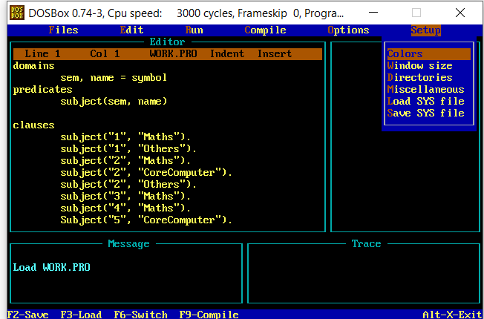

(2) Output screenshot

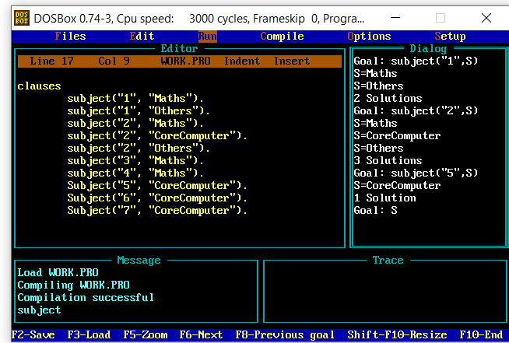

(3) Your understanding of the program/Comment on how this same system can be designed using "c or c++ or java" languages.

Used: Code Blocks

Code:(L1.cpp)

#include<iostream>

using namespace std;

int main()

{

cout<<"Heyy Enter Your Semster No: ";

int sem;

cin>>sem;

cout<<"Here Your Subjects:\n";

switch(sem)

{

case 1:

cout<<"Maths\nOthers";

break;

case 2:

cout<<"Maths\nCoreComputer\nOthers";

break;

case 3:

cout<<"Maths";

break;

case 4:

cout<<"Maths";

break;

case 5:

cout<<"CoreComputer";

break;

case 6:

cout<<"CoreComputer";

break;

case 7:

cout<<"CoreComputer";

break;

}

return 0;

}

Output:

